What will you learn?
Interprofessional Collaboration in HIV Care is Coming to [insert university] for Spring, 2017!
Enroll today and get clinic ready!

Right now, an estimated 1.2 million people are living with HIV in the
United States and 1 in 8 don’t know it.

The good news is that people with HIV are living full and productive lives!

Thanks to highly effective strategies, healthcare professionals are making significant improvements in HIV
prevention and treatment.

- Key principles of interprofessional collaboration and foundational knowledge of HIV/AIDS
- How collaborative practice can impact patient and population outcomes related to screening, prevention and collaborative management of HIV/AIDS
- The roles and responsibilities of advanced practice nurses, dentists, physicians, dieticians, occupational therapists, pharmacists and social workers [modify list to fit your program]
Be a part of an interprofessional team of learners! This curriculum is for learners who want to actively
participate in the learning experience and includes the following:
- A learning community comprised of an interprofessional group of 6-8 students and facilitated by 2 faculty from different professions
- Three in-person sessions (3 hours each) conveniently scheduled during late afternoons with dinner included; scheduled 3 weeks apart for a total length of 9 weeks
- Online synchronous or asynchronous learning – your group decides – in between the live sessions
- A clinical component with immersion in 2 different clinical settings at a HIV/AIDS care provider in Chicago during the last 4 weeks of the program
- The program will be approximately 30 hours or 2 credit hours

For questions, or to enroll, contact [INSERT YOUR CONTACT INFORMATION]

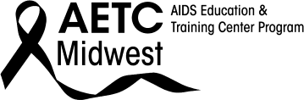

9.12.17

