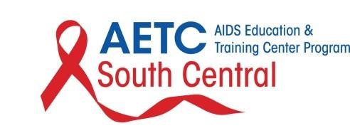 IPE Student Rotation Experience: Outpatient
Student Name:
Educational Institution/Program:
Discipline:
Cohort:
Date:
- What went well/ was the best part of the rotation?
- What could have been done better/ was your least favorite part of the experience?
- What were your experiences with the patient interviews? Do you have any feedback on them?
- (a) Which faculty/ staff in the clinic did a great job? (Please list so that they can get recognition)
(b) Were there any faculty/ staff that were difficult to work with?
- Is there any information or instruction that would have been helpful to have received before starting the outpatient rotation?
OVERALL
- Which experience do you feel you benefited or enjoyed more, inpatient or outpatient and why?
- Would you now consider a career within HIV prevention and treatment?
Implemented January 2018

