Quarterly Newsletter-Spring 2017
AETC Program related news, resources and events:
Resources & Events
13th Annual HIV/AIDS Care in the Correctional Setting - April 1, 2017, 8:45 AM-4:45 PM, Tacoma, WA.
Source: Mountain West AETC, University of Washington STD Prevention Training Center, Oregon AETC at Portland VA Research Foundation
Description: The purpose of this training is to provide an update on the latest clinical information and best practices regarding the care and treatment of people living with HIV infection in the correctional setting. Featured presentations include 2017 HIV Update and Opiate Use Disorder: How Treatment Medications Support Recovery and Save Lives; additional presentations include STI Treatment Update, Hepatitis C & HIV, and Medical Release Planning. This conference is free to healthcare providers working with justice populations. If you do not work in a correctional facility or with recently incarcerated populations, the registration fee is $50 to cover event costs and CME.
Link to event registration

2017 National Latino HIV and Hepatitis C Conference - May 22-24, 2017, San Pedro Island, TX
Source: South Central AETC, Denver Prevention Training Center, Westbrook Clinic
Description: The 2017 National Latino HIV and Hepatitis C Conference aims to provide healthcare and social service providers with innovative concepts, best practices, and new information on how to best serve Latino communities. It will bring together varied disciplines to increase knowledge and awareness about Latinos living with HIV and/or hepatitis C virus (HCV). Workshops will include topics to help increase participants’ knowledge about cultural and social barriers faced by Latinos in seeking/receiving HIV/HCV care and services, increase understanding of the disproportionate impact HIV and HCV infection rates have among Latino communities, increase the ability to develop culturally tailored medical practices and interventions to support Latino patients in achieving viral suppression, and more. The program offers several Spanish language training opportunities for Ryan White providers.
Link to conference site and registration
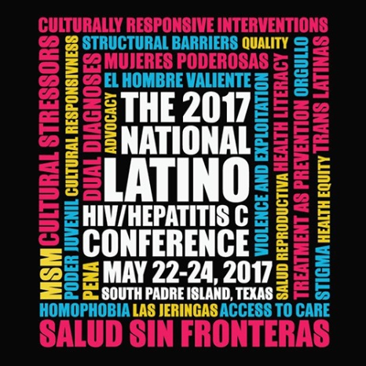

Information for Health Care Providers with Patients Who Have Been Detained by U.S. Immigration and Customs Enforcement (ICE)
Source: Pacific AETC, Los Angeles AETC, Arizona AETC
Description: This document contains general background information about ICE, general considerations for individuals in ICE custody, tuberculosis and HIV continuity of care, and frequently asked questions regarding federal custody.
Link to download factsheet

Substance Use, HIV, and Women: What Providers Need to Know
Source: Pacific AETC, Pacific Southwest Addiction Technology Transfer Center, Charles Drew University
Description: The purpose of this introductory training is to provide HIV clinicians and allied healthcare professionals with a detailed overview of substance abuse and HIV among women. The curriculum reviews important epidemiological data focused on substance use trends in women and HIV prevalence; reviews standardized screening and assessment techniques to support the move to improve treatment effectiveness; and concludes with evidence-based and promising clinical strategies. The introductory training includes a 112-slide PowerPoint presentation, Trainer Guide, and a companion 2-page fact sheet.
Link to training materials
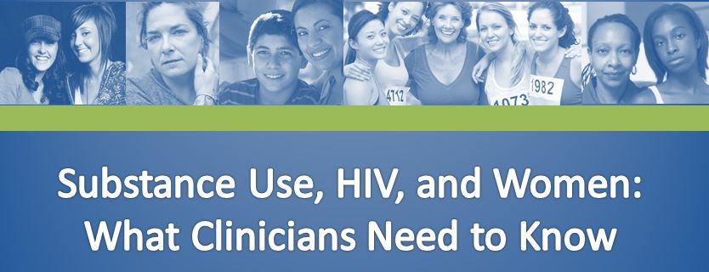

Prescribing PrEP for HIV Prevention - A Guide for Medical Providers
Source: Mountain West AETC, Cascade AIDS Project
Description: This easy to use guide provides indications, contraindications, how to prescribe, and other needed information for prescribing PrEP. This resource can be customized for regional AETCs only.
Link to resource
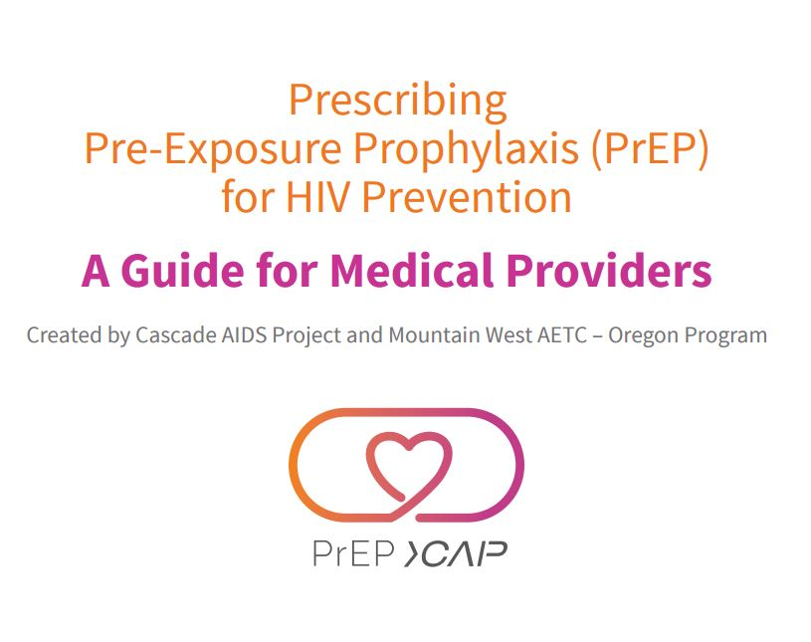

Updates from the National Clinician Consultation Center (NCCC):
- Program Announcement:

  - NEW PEPline Hours – Beginning March 1, 2017, the NCCC’s Post-Exposure Prophylaxis Hotline (the PEPline) will be available from 9:00 am until 9:00 pm, Eastern Time, seven days per week at the same number: 1-888-448-4911. Please note that wait times may increase due to these changes. Visit the NCCC website for additional resources in managing occupational and non-occupational exposures to HIV and hepatitis B and C.
- Case of the Month:
  - Review of Anal Cancer Screening for HIV-Positive Patients - Anal cancer rates are rising among people living with HIV, yet there are currently no standard national recommendations for routine screening.
  - Concurrent Heroin and Methamphetamine Use Disorder - As a clinician, how would you approach and prioritize concurrent substance use disorders? What evidence-based approaches exist to treating stimulant use disorders?

- Recent publication:

  - Preexposure Prophylaxis in the United States: An Evolving HIV Prevention Opportunity. Clin Infect Dis. (2017) 64 (2): 150-151 doi:10.1093/cid/ciw705

Save-the-date: 2017 Ryan White HIV/AIDS Program (RWHAP) Clinical Conference – August 21-23, 2017, San Antonio, TX
Source: AETC National Coordinating Resource Center (NCRC), International Antiviral Society-USA (IAS-USA)
Description: The Health Resources and Services (HRSA), HIV/AIDS Bureau funded AETC Program’s 17th RWHAP Clinical Care Conference will take place at the Hyatt Regency San Antonio in San Antonio, Texas. This technical conference will provide state-of-the-art research, care, and treatment updates for experienced clinical decision makers (physicians, advanced practice nurses, and physician assistants) who are responsible for the day-to-day medical care and treatment of persons living with HIV and those integral to the provision of medical care in HRSA funded RWHAP sites.
Detailed agenda with topics and speakers, venue description, information about CE credits, and details about attending and travel will be posted on the AETC NCRC website (aidsetc.org) and the IAS–USA website (iasusa.org), as they become available. Online registration will open in early April.
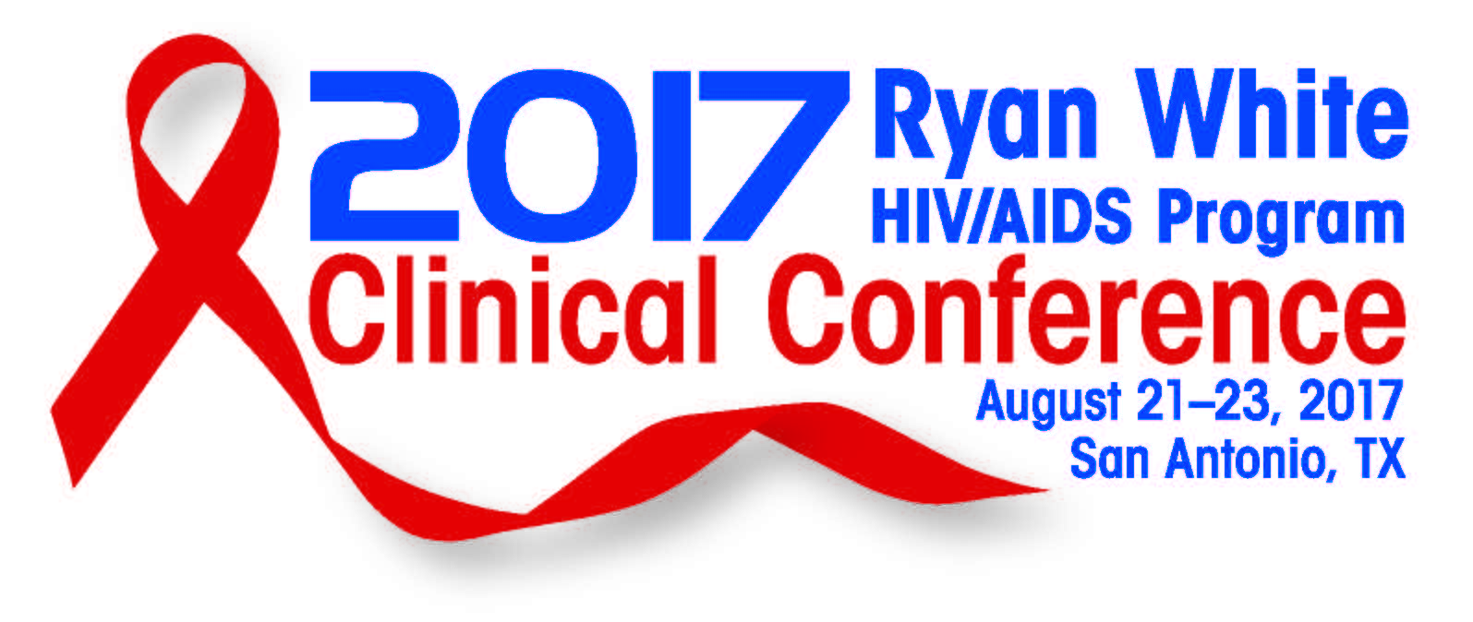
Minority AIDS Initiative
Changes in the Disparity of HIV Diagnosis Rates Among Black Women — United States, 2010–2014
Source: Morbidity and Mortality Weekly Report (MMWR), U.S. Centers for Disease Control and Prevention, U.S. Dept. of Health and Human Services
Description: This report reveals that HIV diagnosis rates among women decreased from 2010 to 2014. The greatest rate decrease occurred among black women, followed by Hispanic women, and then white women.
Link to full report

Well Versed
Source: National Alliance of State and Territorial AIDS Directors
Description: This is a new online community that bridges the communication gap between Black men and their healthcare providers. It provides content to help guide and support healthy dialog before, during and after the visit, and includes a directory connecting Black men to healthcare providers.
Link to website
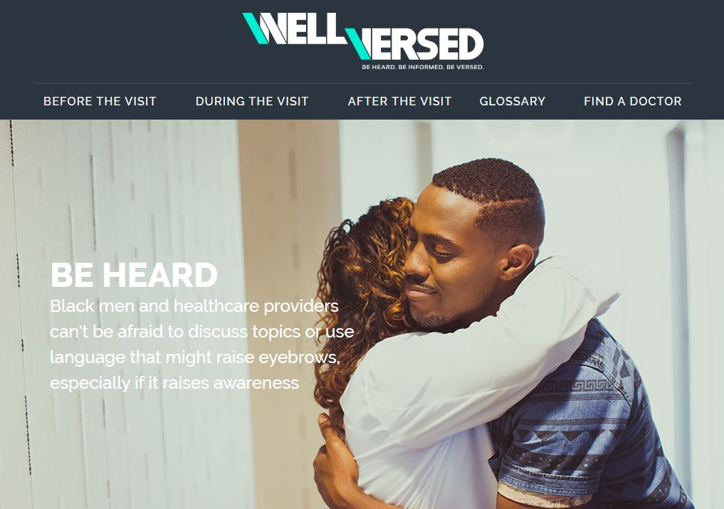

Practice Transformation
How to Improve with the Model for Improvement (online course)
Source: Institute for Healthcare Improvement, Associates in Process Improvement
Description: This free quality improvement course is designed to teach basic steps in any improvement project: setting an aim, selecting measures, developing ideas for changes, and testing changes using Plan-Do-Study-Act (PDSA) cycles. The Model is simple to understand and apply; during the course you’ll have the chance to test some of the techniques on your own personal improvement project. CEUs are provided for a range of audiences, and its estimated time for completion is 1 hour 30 minutes.
Link to course modules

Interprofessional Education

2017 Interprofessional Education Summit - April 11, 2017, St. Paul, Minnesota
Source: National Center for Interprofessional Practice and Education, University of Minnesota
Description: This conference aims to address the importance of healthcare teaming, who and what makes a great team, and how to measure effectiveness. This year’s summit will include keynote addresses, breakout talks, and poster sessions that will address questions like, what makes a team effective and high performing, and can team skills be taught? The Summit will take place at the Henrietta Schmoll School of Health and St. Catherine Univerisity.
Link to event registration

Other resources, news and events:
The Case for Behavioral Health Screening in HIV Care Settings
Source: U.S. Dept. of Health and Human Services, Substance Abuse and Mental Health Services Administration - Health Resources and Services Administration (SAMHSA-HRSA) Center for Integrated Health Solutions
Description: This report lays out the clear need for HIV treatment providers to jointly address behavioral health concerns and HIV, starting with screening for mental health and substance use disorders. It offers strategies for providers to implement screening practices, including tips for preparing staff, updating organizational culture and enhancing organizational infrastructure. Free print and digital versions are available.
Link to resource
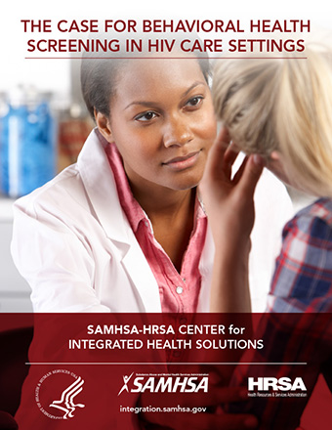
2017 National Sexual Health Conference, July 6-8, 2017, Denver, CO
Source: Denver Prevention Training Center, American Sexual Health Association, Program in Human Sexuality, Colorado Department of Public Health and Environment
Description: The 2017 National Sexual Health Conference aims to create opportunities to share information, efforts and best practices around sexual health through education, advocacy, and clinical care, among others approaches. Increasing knowledge, communication and respectful attitudes regarding sexual health, and the use of evidenced-based educational, clinical and other preventive services that improve sexual health, while decreasing adverse health outcomes including HIV, STIs, viral hepatitis, unintended pregnancies and sexual violence, are among some of the conference goals.
Link to conference site & registration

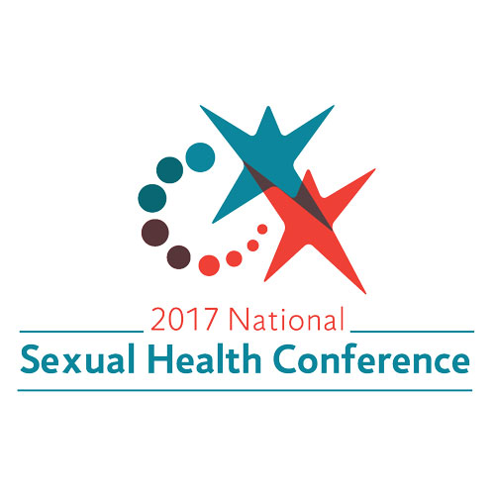
Clinician Guidelines on HIV Criminalization
Source: Association of Nurses in AIDS Care (ANAC), Elton John AIDS Foundation
Description: This guide was developed for healthcare providers to help address factors that contribute to HIV criminalization, which are based on laws and policies adopted during the time of limited understanding of HIV and HIV transmission risk. In 2015, ANAC and the American Nurses Association called for the end to unjust HIV criminalization and a modernization of existing HIV laws. This guide supports that effort; however, it does not replace or supersede existing laws, professional and ethical standards, practice standards or institutional policies.
Link to download the guide
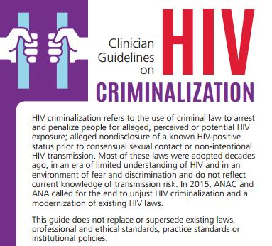

New HIV-related articles on Consultant360
Source: Consultant360, HMP Communications LLC
Description: New HIV-related articles have been added to the HIV/AIDS topic page on Consultant360, an online resource for clinicians. Create an account at the link above to read the following:
- Study: Smoking Effects Lifespan in HIV Patients More than the Virus Itself-
A recent study investigated the effects of smoking on life expectancy in individuals infected with HIV.
- Vitamin D Deficiency Linked to Risk of Myalgia in HIV Patients-
The relationship between vitamin D deficiency in HIV-infected persons and statin-related symptomatic muscle pain was explored by researchers in a new study.
- Study Examines Link Between HIV and Risk for Lung Cancer-
In a recent study, researchers sought to examine the relationship between longitudinal measurements of immune function and lung cancer risk in individuals with HIV.
- Study: Link Found Between Genital Bacteria and HIV Acquisition Risk-
A recent study examined the vaginal bacteria in HIV-uninfected women to determine if the presence of certain bacteria reduced or increased the risk for HIV infection.

Awareness Days
National Women and Girls HIV/AIDS Awareness Day – March 10
National Native HIV/AIDS Awareness Day – March 20
National Youth HIV & AIDS Awareness Day – April 10
National Transgender HIV Testing Day – April 18
HIV Vaccine Awareness Day – May 18
Hepatitis Testing Day – May 19
National Asian & Pacific Islander HIV/AIDS Awareness Day – May 19
HIV Long-Term Survivors Day – June 5
Caribbean American HIV/AIDS Awareness Day – June 8

