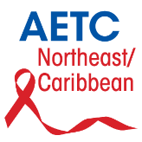

Northeast/ Caribbean AIDS Education and Training Center

Universidad de Puerto Rico • Recinto de Ciencias Médicas

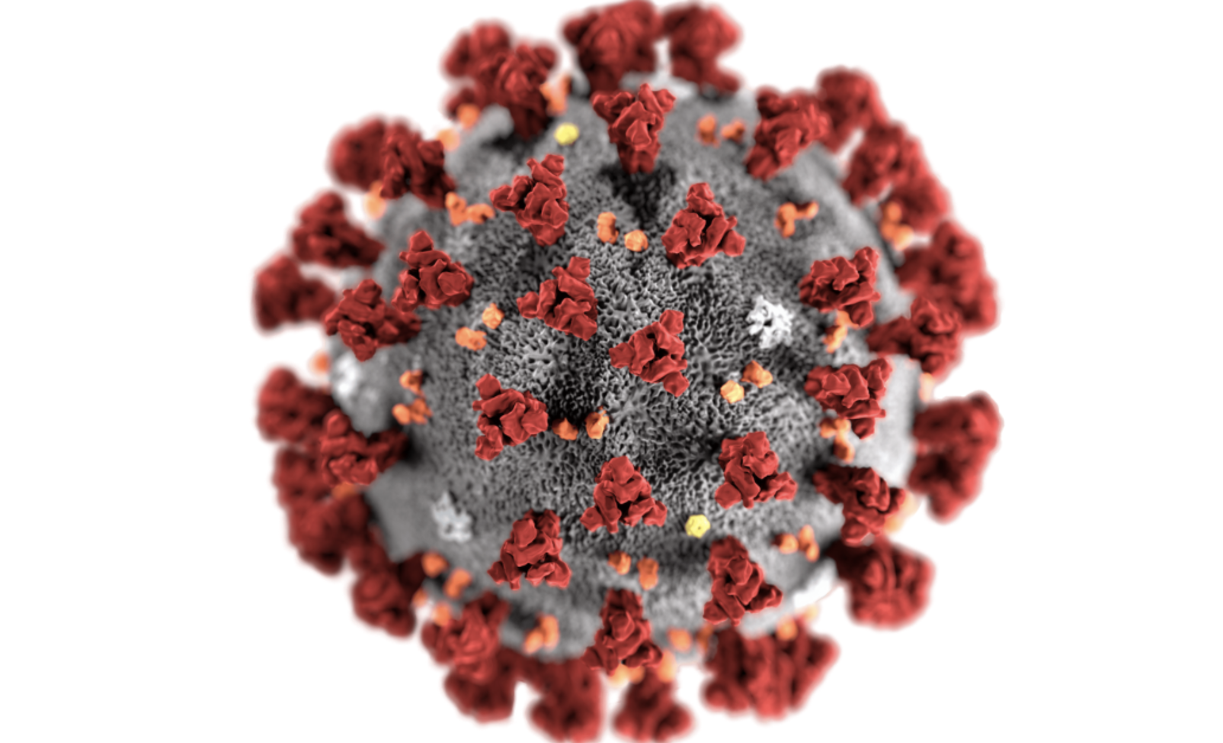COVID-19 and People with HIV

Questions and Answers

Is COVID-19 worse in people with HIV?

No. There is currently no reason to believe that people with HIV who are on effective treatment are at a higher risk of getting COVID-19. There is also no reason to believe you would be more likely to develop severe COVID-19 symptoms if you are managing your HIV well.

Are some people with HIV more at-risk of getting ill?

People with HIV who have a compromised immune system should be extra cautious to prevent coronavirus infection. These include people with

* a low CD4 count (<200 copies/cell),
* a high viral load,
* or a recent opportunistic infection (for example, tuberculosis (TB)

This is because your immune system may not be prepared to deal with the virus. We also know that people with HIV are more vulnerable to respiratory infections when their HIV is not well managed. For this reason, it is very important to be taking your antiretroviral treatment as prescribed, always, but especially during this time. Talk to your health provider if you are currently not taking treatment or if you are struggling with adherence.

Like in people not living with HIV, older people living with HIV and those living with underlying health conditions should also be vigilant.

I am a person with HIV; how can I prevent COVID-19?

The advice for people with HIV is mostly the same as everyone else.

Information about transmission and prevention of COVID-19:

At the present time the Puerto Rico Department of Health recommends staying at home until the propagation of COVID-19 decreases, although the reopening of the economy has begun. If you must go out, wear a mask, and keep the minimum physical distance recommended of 6 feet (2 meters).

If you are part of any of the risk groups that could develop severe symptoms associated to COVID-19, limit physical contact to as few people as possible, ideally to only those who live with you.

I am a person with HIV, what should I do if I feel unwell?

If you are feeling unwell, have a persistent dry cough, fever, and/or loss or change in sense of smell or taste, stay at home and call your health care provider. They will be able to tell you your next steps.

During this time, make sure you avoid close contact with others. Most cases of COVID-19 are mild and will pass after seven to fourteen days from when symptoms started.