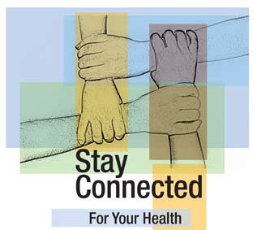Keep all of your clinic appointments

Stay Connected

Take control of your health by seeing your health care providers regularly.

STAR Health Center University Hospital of Brooklyn

445 Lenox Road, 1st floor, Suite J Brooklyn, NY 11203

(718) 270-3745 www.hivcenter.org

Clinic Hours:
Monday, Tuesday, Friday, 9am–5pm
Wednesday, 9am–8pm
Thursday, 1:30pm–5pm

CS125297

Keep all of your clinic appointments.

Your health depends on it!

How to
Stay Connected

• Keep all of your scheduled clinic appointments.

• Work as a team with your health care providers.

• Talk openly and honestly with your health care team.

• Ask questions that are important to you.
Why Is It Important to Keep All of Your Clinic Appointments?

Your Health Depends on It!

At your appointments

• We can check your health and make changes to your treatment plan if needed.

• We can give you the best medical care.

• You can take control of your health.

In one large study, people with HIV who attended all of their clinic appointments lived longer.

Source: Clinical Infectious Diseases, 2007.

Remember—it is important to come to all of your clinic appointments whether you feel sick or feel well.
Ways to Remember Your Clinic Appointments

❑ Write all of your appointments in a calendar.

❑ Put reminders or alerts in your cell phone.

❑ Put your reminder card in a place where you will see it often.

❑ Make sure we have your correct telephone number and address.

❑ Let us know right away if your telephone number or address changes.

If something comes up and you can’t keep a clinic appointment, please call us at least 2 days in advance. It is important to reschedule if you
miss an appointment.

