

Preconception and Contraceptive Care for Women Living with HIV
Toolkit Request Form

ORDERING
EMAIL to fxbcenter@umdnj.edu (please include “Preconception Care Toolkit” in subject line and attach this order form)
Ms. Anne Reilly
François-Xavier Bagnoud Center
School of Nursing, University of Medicine and Dentistry of NJ
65 Bergen Street, 8th floor
Newark, New Jersey 07101 USA
Phone: 973-972-9224 Fax: 973-972-0397

CONTACT PERSON  Name:  Organization:  Address  Phone:  Email: | SHIP TO  Name:  Organization:  Street Address:  City, State, Zip:  Phone:  Email:

Number and Title of Tool | Quantity Requested
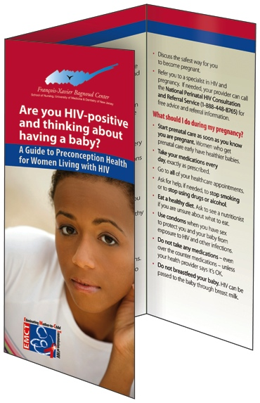
Tool #1 – “Are You Thinking About Having a Baby?” An informational brochure for patients that defines preconception health and explains the importance of preconception care for women living with HIV.

Tool #2 – “Living a Healthy Life” A postcard for patients that encourages them to take steps to ensure they stay healthy. One side with advice for women and the other side for men.

Tool #3 – “Preconception Counseling for Women Living with HIV”A counseling guide for providers with suggested scripts for discussing fertility desires and preconception care with women of reproductive age living with HIV.
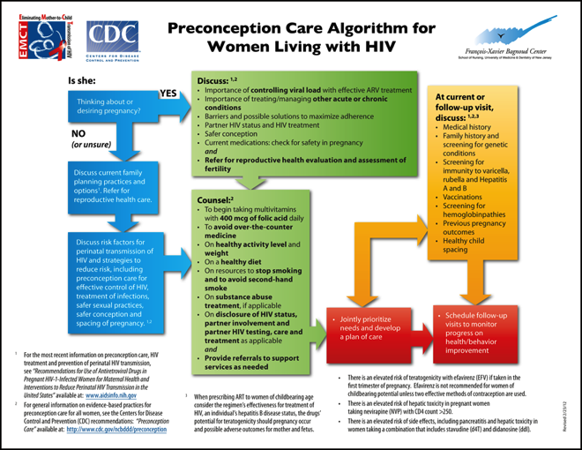
Tool #4 – “Preconception Care Algorithm for Women Living with HIV” An algorithm for HIV providers showing the components of preconception care for women living with HIV who are of reproductive age
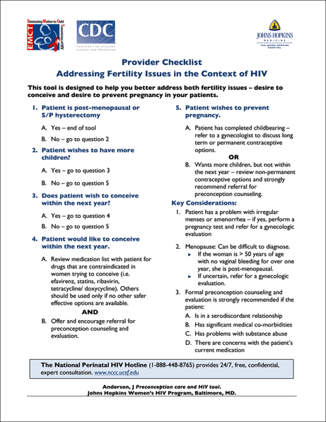
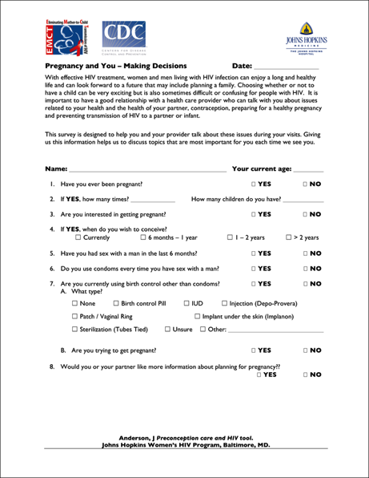
Tool #5 – “Client questionnaire and provider checklist” This is a two–part tool to support preconception care. The front side is a patient questionnaire that explores fertility desires and basic reproductive history. The back side is a provider checklist to provide guidance on providing basic contraceptive and preconception counseling and care during a primary care visit.
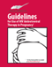
Tool #6 – “Guidelines for the Use of Antiretroviral Therapy in Pregnancy” (pocket guide) US-based treatment recommendations for antiretroviral therapy to prevent transmission during pregnancy sand for infants exposed to HIV.
- Please note that we will send as many copies of the requested tool(s) at no cost. However, our supplies are limited and we ask that you provide an account number or mailing label to cover the cost of shipping.
- Electronic copies are also available in PDF format online at http://aidsetc.org/aidsetc?page=etres-display&resource=etres-658 OR http://www.fxbcenter.org/resources.html (Scroll down for Clinician Resources)
- Please allow 2-3 weeks for delivery.

