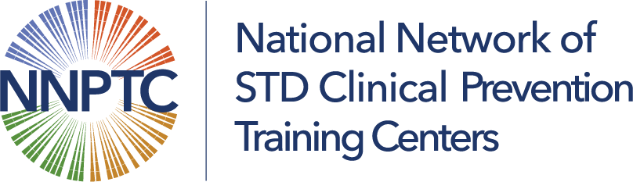

Utilizing Producers in a Virtual Setting
In order to distinguish between various types of virtual learning the NNPTC set forth standardized definitions to capture the level of effort of staff, the expectations of participants, and to better evaluate the outcomes in virtual learning environment. We use the terms webinar, live web stream, learning community & virtual classroom, and there are distinct differences between the levels of student participation in all of these. For the purposes of this session I am going to focus on the modalities of a virtual classroom, but these tools can be applied to all.
So much goes into preparing for an interactive experience with your participants in all these modalities, it requires a great deal of multitasking. In fact, in the virtual classroom setting where the students are not only absorbing the didactic information, but also applying what they have learned. Best practices suggest engaging your learner by asking them to do something every 3-5 minutes using chat, polling, feedback icon, breakout group or a whiteboard.
HOW IS THIS POSSIBLE? Let me introduce, the producer. The producer is the wizard in the movie, “The Wizard of Oz”. The person behind the curtain who works the magic to make the technical aspect of the training run smoothly, while the facilitator/trainer presents the content & engages the learners. Anyone can be trained to play this role, we use our administrative staff to assist.
Here is a sampling of producer duties:
- Prepare the virtual tools to be used in the session.
- Conduct a class warm-up with the participants before the session begins.
- Handle technical support issues for the participants and the facilitator.
- Oversee the chat area and monitor for questions from the participants.
- Alert the facilitator to raised hands or chat questions they may not have noticed.
- Annotate/scribe on the whiteboard while the trainer facilitates the exercise.
- Act as a back-up if the facilitator’s internet connection is lost.
- Answer questions to generate participation if its slow to start.
The goal is to be “in syn” with your producer & work together like Fred Astaire & Ginger Rogers.

Here is how to become a dynamic duo!
- Follow the same detailed lesson plan as it will clarify both the facilitator and producer roles.
- Rehearse together at least two weeks prior to the session.
- Establish rules for how to deal with participant-related problems. For example, who will answer questions in the chat area.
- Have a contingency plan for dealing with unexpected emergencies. For example, what happens if the facilitator loses connection to the virtual classroom.
- Determine how you will communicate outside of the virtual classroom. For example, text via cell phone or use an instant messenger program.
- Support and always look out for each other.
- Document lessons learned after every online session for your own professional development and for other facilitator/producer teams who will teach the same course in the future.

****** See the Resources Below****

NNPTC Definitions of Types of Virtual Training
In order to distinguish between various types of virtual learning the NNPTC set forth standardized definitions to capture the level of effort of staff, the expectations of participants, and to better evaluate the outcomes in virtual learning environment.
- Webinar: A presentation delivered to a large audience for duration of no longer than 90 minutes.
- Live Web Stream: Unidirectional video with participant feedback through chat and/or audio. Didactic content t lasting 90 minutes or longer and/ or over consecutive days.
- Learning Community: Are typically planned monthly and delivered once per month and the cohort shares common goals. Typically, learning communities have a cohort, which stays the same and attends each session. There is a rotating panel of experts that present approximately 5 minutes each. The facilitator encourages peer learning and questions to the panel. (ECHO Model)
- Virtual Classroom: Bidirectional video that includes both didactic and application (i.e. case studies, virtual skills practice sessions, quiz) in a virtual classroom environment. Best Practices: Engage the learning in some sort of feedback every 3 to 5 minutes.

Zoom Resource Tools for Participant Engagement in a Virtual Classroom
- Polling Participants
  - Webinars: https://support.zoom.us/hc/en-us/articles/203749865-Polling-for-webinars
  - Meeting: https://support.zoom.us/hc/en-us/articles/213756303-Polling-for-meetings

- Using Chat
  - Announcements: https://support.zoom.us/hc/en-us/articles/360037120072-Using-chat-announcements
  - Webinars: https://support.zoom.us/hc/en-us/articles/205761999-Using-webinar-chat
  - Meeting: https://support.zoom.us/hc/en-us/search?utf8=%E2%9C%93&query=using+chat
  - Sending files: https://support.zoom.us/hc/en-us/articles/202920879-Sending-a-screen-capture-file-reaction-or-audio-message
  - Chat Waterfall: Set up a “Chat Waterfall” to encourage interaction: ask the class a question, and then instruct your students to write their answers in the chat box, the chat box will flood with answers.

- Breakout Rooms:
  - Enabling: https://support.zoom.us/hc/en-us/articles/206476093-Enabling-breakout-rooms
  - Managing: https://support.zoom.us/hc/en-us/articles/206476313-Managing-Breakout-Rooms
  - Participating: https://support.zoom.us/hc/en-us/articles/115005769646-Participating-in-breakout-rooms
  - Pre-assigning Participants: https://support.zoom.us/hc/en-us/articles/360032752671-Pre-assigning-participants-to-breakout-rooms

- Whiteboards
  - Sharing: https://support.zoom.us/hc/en-us/articles/205677665-Sharing-a-whiteboard
  - Annotation Tools: https://support.zoom.us/hc/en-us/articles/115005706806-Using-annotation-tools-on-a-shared-screen-or-whiteboard

- Non-verbal Feedback& Reactions:
  - Emojis: https://support.zoom.us/hc/en-us/articles/115001286183-Non-verbal-feedback-and-reactions

